Welcome To The Leadership Initiative

Vision: Where We Are Going.
- To create a consulting company that caters to visionary entrepreneurs and not just overwhelmed workaholics. At The Leadership Initiative we are committed to helping entrepreneurs create a business that will run without them so they can live the life they were designed to live. Our Coaching Sets Business Owners Free!

About Clay Staires –
Clay was a high school teacher and head coach for 15 years. He received honors as the Teacher Of The Year and The Missouri State Coach Of The Year. He also has
10 years of executive experience in the non-pro t sector where he led an award winning company, rede ned a 30-year-old brand and successfully led the company through it’s biggest transition in it’s 40 year history.
After starting six successful businesses in ve years, today Clay lls his days as the CEO of The Leadership Initiative, creating con dent leaders that can produce winning results and improve lives. He also speaks nationally as a motivational speaker. Locally, the Skiatook Chamber of Commerce named him the “2012 Citizen of the Year” for the positive impact his programs have made on their community.

Clay is ranked the #1 Motivational Speaker in Oklahoma by GigMasters.com, a national online booking agency! He has shared the stage with CEO’s of the worlds largest companies and New York Times Best Selling Authors, speaking to groups from 15 to 5,000. Clay provides an electric experience lled with entertainment and profound personal impact.
Clay Staires has spoken nationally in front of groups that come together to be inspired, encouraged, motivated and challenged. His humor and interactive style has drawn audiences in and held their attention all the way through a climactic ending that involves powerful personal decisions to engage in life, in job responsibilities and in personal relationships.
Clay’s messages center around personal and professional growth. Clay is able to talk about life transitions and organizational transitions in a very thoughtful, meaningful, and humorous way. He takes his audience on a journey of discovery and enjoyment.

HOW DID WE GET HERE? OUR HISTORY

The Fam! Maddy, Lisa, Clay, Clare

Back in the year 2000, I had been a schoolteacher for 11 years and, even though I was really enjoying it, I was realizing that this “vehicle” wasn’t going to get me to the future I desired. I was living in Kansas City, newly married, two daughters and stressed out over time and money. Life was OK, but it wasn’t I knew there was more for me than what I was currently living. To move toward my dream life would require some big changes.
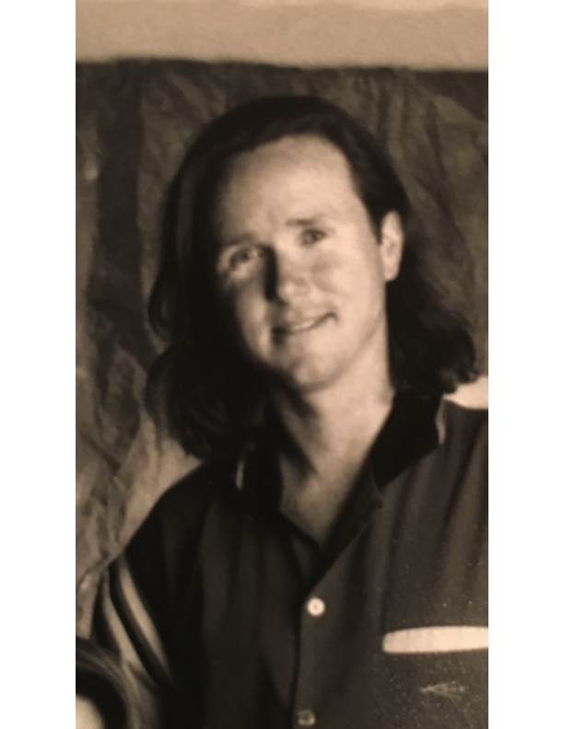
In 2002, my wife and I made those changes. We left Kansas City and moved to Oklahoma (home for me) to take over the family business that my parents had started back in 1972 – Shepherd’s Fold Ranch – a Christian Summer Camp and Retreat Property. Wow, we loved it! 100 acres with 20 horses, a huge log home with a pool and about 1000 friends coming to visit us each summer! It was my first step into the “business” world and I did pretty good in some areas but terrible in others. I leaned on my passion and background in teaching, coaching, inspiring and writing curriculum to design training programs for young leaders. My “clientele” had changed from high school students to college-aged students. However, by 2008, again I began to feel that this “vehicle” wasn’t going to get me to the future that I dreamed of. I knew there was more to me than I had fully accessed.

In 2012, we left SFR and started building a company based on leadership coaching and motivational speaking. This is what I had been doing for 25 years. It’s what I knew and what I was confident in. Within two years, we had a full load of clients and speaking gigs and our income had already surpassed my teaching salary! Our business was up and going and I began to coach other business owners along the same pathway that I had walked. By 2015, our client load had shifted to become business owners that were imprisoned by their companies. Helping these business owners create a company that would run without them became the focus of all of our coaching.

By the beginning of 2017, our monthly revenues had surpassed what I was making in a full year as a schoolteacher and I was only working three days a week! This vehicle was working! It was creating the time freedom and financial freedom that I desired for my life.

Today, I help hundreds of people each year along their path to freedom. We have designed specific steps for overwhelmed business owners to move toward being successful entrepreneurs. We call it the Staires Steps To Freedom and we have used it to help hundreds of business owners clearly see the path they need to follow as they create a business that will run without them.

Purpose: The Reason We Are Going There.
Through delivery of excellent coaching and deliverable systems we will provide solutions to following three issues facing our countries entrepreneurs:
1) People Management – According to the State of the American Workplace and a 2013 Gallup Study, 70% of Americas Workforce is disengaged. 24% of these are “actively disengaged”, whatever that means. Disengaged Employees cost the U.S. between $450 and $550 Billion each year in lost productivity. 46% of new hires fail within first year. 89% of these failures are due to poor cultural fit. Turnover costs are estimated to be 100% -300% of the base salary of the replaced employee. Our proven coaching system equips entrepreneurs to get the right people in the right seats and consistently evaluate employees so they can prune as needed. This creates Time Freedom for the owner.
2) Work Management – Our in-house surveys reveal that 87% of the entrepreneurs and business owners that we reach each year do not feel confident in how to fix the problems in their company. They have a talent to do the work, but they are quickly over their head when it comes to managing all the details that need attention in a successful company. 82% of these business owners feel trapped in the weeds of all the daily work and don’t have time to get their head up and look ahead. Our proven coaching system trains and equips business owners in how to create systems to manage work so they don’t have to. These systems allow business owners to put the weight of their business on the back of processes instead of people. This creates Time Freedom for the owner.
3) Cash Management - In 2012, according to the Census Bureau, there were 5.73 million employer firms in the U.S. Firms with fewer than 20 workers made up 89.6% of those businesses. Inc.com tells us that 96% of businesses will fail within their first 10 years (only 4 out of 100)! Companies go out of business because they don’t manage their cash and can’t pay their bills. Our proven coaching system equips entrepreneurs with the tools necessary to manage their cash flow so they can grow their business. There is a huge difference between having profits and having cash! This creates Financial Freedom for the business owner.

Core Values: How We Got Here
- High Energy - Regardless of the temperature and the attitudes of those around you bringing relentless positivity and a commitment to doing the right thing to every situation.
“Approach every meeting with a purposeful, high-energy, ready-to-make-a-contribution attitude, and watch how fast leadership’s perception of you follows your behavior.” Jack Welch

- Production - Never be satisfied; strive for excellence in all that you do.
"Be a yardstick of quality. Some people aren't used to an environment where excellence is expected." - Steve Jobs (Founder of Apple)

- Team – have the capacity to view a goal through the lens of the whole rather than just your individual part. Focused on winning and not just staying busy.
"On a football team, it’s not the strength of the individual players, but it’s the strength of the unit and how they all function together.” Bill Belichick

- Personal Growth – passionate about growing, learning, expanding and experiencing more. Being the enemy of average.
"Income seldom exceeds personal development.” Jim Rohn

Our Culture:
- “There is a pace to success.” Clay Staires
- “I look for 3 things when hiring; integrity, intelligence and a high energy level. But if you don’t have the first, the other two will kill you.” Warren Buffett
- “Knowledge without application is meaningless.” Thomas Edison
- “Action is the real measure of intelligence.” Napoleon Hill
- “If you actions inspire others to dream more, learn more, do more and become more, you are a leader.” John Quincy Adams
- “A small team of A+ Players can run circles around a giant team of B and C Players.” Steve Jobs
- “A player who makes a team great is more valuable than a great player. Losing yourself in a group for the good of the group; that’s teamwork.” John Wooden
- “You will either step forward into growth or you will step backward into safety.” Abraham Maslow
- “Nothing grows unless you do.” Maya Angelou
- "Diligence is the mother of good luck." - Benjamin Franklin (One of the Founding Fathers)
- "There is only one boss. The customer. And he can fire everybody in the company from the chairman on down, simply by spending his money somewhere else." - Sam Walton (Founder of Wal-Mart)
- "Going the extra mile is the action of rendering more and better service than that for which you are presently paid. When you go the extra mile, the Law of Compensation comes into play." - Napoleon Hill (Most successful self-help author of all-time)
- "Control your own destiny or someone else will." - Jack Welch (CEO of GE)

Strategy: How We Will Get There.
- We focus on marketing exclusively to entrepreneurs who appreciate the value of learning and growing through the relationship with an experience coach that has a proven path.
- We will be the leader of the business coaching industry by paying extreme attention to detail and offering products and services of uncompromising quality.
- Encourage creativity and excellence by meeting with our local business owners for ongoing training to mentor them as people and professionals.
- We provide our client community with an energized, upbeat, positive and enjoyable atmosphere that creates the feelings of hope and inspiration. The Leadership Initiative ambiance is achieved by filling each location with inspirational decor that is professional, upscale and warm.
- We relentlessly listen to our clients to understand and adapt to their present and future needs.

Contact Information

Address: 1100 Riverwalk Terrace
Jenks, Oklahoma

Phone: 918-798-0852

Owner: Clay Staires
Phone (C): 918-798-0852

Email: clay@claystaires.com

Cultural Expectations:
The Leadership Initiative’s Standard of Excellence
“You don’t hire for skills, you hire for attitude. You can always teach skills.” – Herb Kelleher, founder of Southwest Airlines, the worlds largest low-cost carrier

- Have a positive attitude in every situation
"Every adversity, every failure, every heartache carries with it the seed on an equal or greater benefit." - Napoleon Hill (Best-selling self-help author of all-time)
- Be a problem solver- you must be a forward thinking solution-orientated person to work at the The Leadership Initiative.
- Take "Emotion out of the Motion"- You must not be led by your emotions. You must be able to put your emotions to the side so that you can resolve issues with a team first mentality.
- Respect- Show people how to respect YOU by the way you respect THEM.
- Leadership- You must do more than you expect from others to become a leader at The Leadership Initiative.
- "One of the penalties of leadership is the necessity of willingness, upon the part of the leader, to do more than the part he requires of his followers." - Napoleon Hill
- Exceed Customers Expectations- always go above and beyond when dealing with customers. Keeping in mind that the details are what make the difference in customer service.
- "I can't" is not part of our vocabulary- It’s not “I can’t” it’s “how can I” that is the real question. Where there is a will there is a way.
- Tobacco Free Facility- No tobacco usage within or around The Leadership Initiative Facility.
- Curse Free Facility- No cursing within The Leadership Initiative Facility.
- No Inappropriate Slang- To communicate effectively with clients and each other, proper language is expected to be used with The Leadership Initiative environment.

“We will hire someone with less experience, less education, and less expertise, than someone who has more of those things and has a rotten attitude. Because we can train people. We can teach people how to lead. We can teach people how to provide customer service. But we can’t change their DNA.” – Herb Kelleher

Your Personal Growth:
It starts with one

The Problem
- 80% of the people working in the workplace are stuck in a rut.
- Most people in the workplace feel like they know everything.
- Most people in the workplace jump from shop to shop believing that if the company they worked at had a better location, more traffic, more advertising and better people then they would be happy.
- Most people have a job (Just Over Broke), which is getting them nowhere quickly.

The Solution
- At The Leadership Initiative we are focused on being the best in the industry, so as a byproduct of our focus you will be taught how to jump into the top 20% of the industry.
- As a top 20% professional you will make more than most people, you will work with a better clientele than most people, and you will have more room for advancement than most people in the industry.
- We will help you change your life if you are willing to study successful people, do what they do and change the way you think.

Are You A Diligent Doer or a Happy Hoper?
- A Diligent Doer is someone who has mastered the ability to turn their hopes and dreams into clearly defined goals. These people have a crystal clear vision of today as well as tomorrow.
- A Happy Hoper is someone who says, “I hope to be successful someday”, “Someday I’m going to own my own business”, “I wish I could make more money.” Happy Hopers never get to where they want to go because they don’t have a specific action plan in place to get them from point A to point B. Until you have learned how to become a Diligent Doer you are a Happy Hoper.

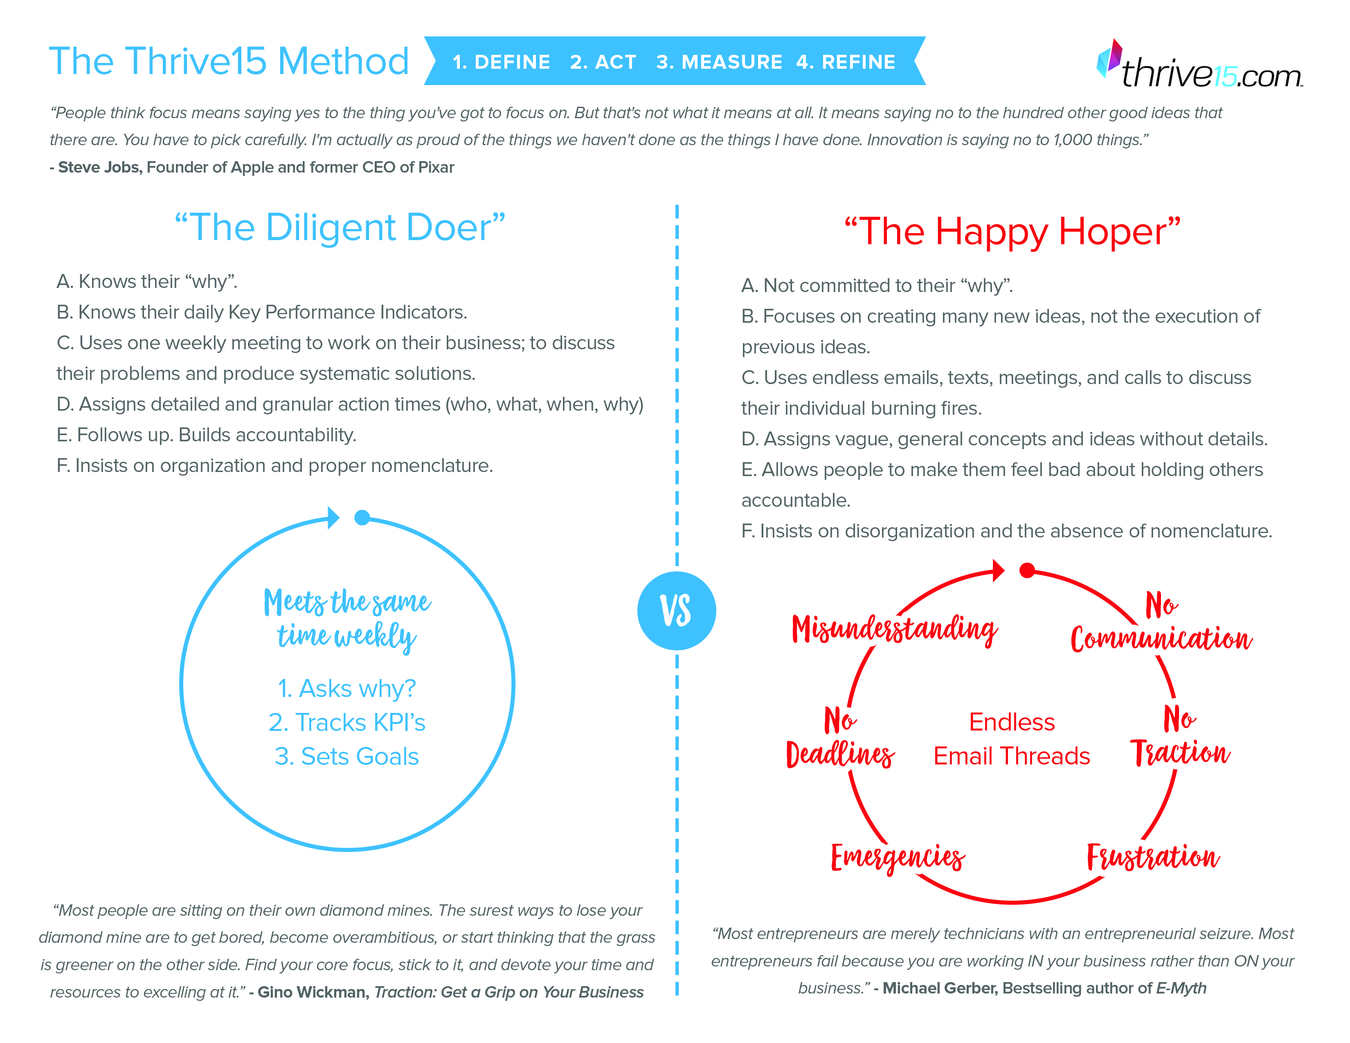
“If you create an environment where the people truly participate, you don’t need control. They know what needs to be done and they do it. And the more that people will devote themselves to your cause on a voluntary basis, a willing basis, the fewer hierarchies and control mechanisms you need.” – Herb Kelleher

Being S.M.A.R.T. at Setting Goals
Bridge the Gap Between Being a Happy Hoper and a Diligent Doer

- Specific - The problem with some goals is that they are too vague and general to do you any good. Having a specific goal keeps your attention and energy focused. If your goal is too vague, you will not know exactly where to direct your efforts.
- Measurable - By making your goals measurable and tracking your results you are able to keep score and judge if you are improving. You must utilize the daily tracking systems we have in place if you are going to make progress. And yes, it does take extra time to keep track. If success were easy everyone would be successful. How long do you have to track? Forever.

- Number of Services
- Number of Clients
- Number of Product Sales
- Number of Memberships
- Hours Worked
- Tips
Accomplish Your Goals:
"Vision without execution is just hallucination"
- Thomas Edison (The man who invented the light bulb, recorded sound and recorded video)

- Action-Orientated - A smart goal will have specific action steps on which to focus attention and behavior.
- Relevant - Look for the connection between achieving your goals and your personal life improving. Because you are trying to improve yourself, your goals must be intended to stretch you, yet be within your reach.
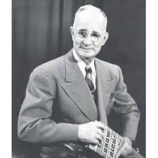
"All successful men and women are big dreamers. They imagine what their future could be, ideal in every respect and they work every day toward their distant vision, that goal or purpose." - Brian Tracy (Success author and multimillionaire businessman)
- Time-limited - Setting a deadline for achieving your goals will help you to avoid procrastination and motivate you towards your goal.
"A goal is a dream with a deadline."
- Napoleon Hill (Best-selling self-help author of all-time)
Written Goals:
- At The Leadership Initiative it is very important to us that we help you achieve your goals. To help you get from where you are to where you want to be we want to keep file of your one year, three year and five year goals. At The Leadership Initiative we realize that everyone is either green and growing or ripe and rotten.
- At The Leadership Initiative we are committed to helping you reach your goals. In order to insure that you become the best person you can be we consistently follow up with you to make sure that your daily action steps are parallel with your goals. We want to make sure you are held accountable to yourself in the area of self-development.

"As I grow older, I pay less attention to what men say. I just watch what they do."
- Andrew Carnegie (One of the world's wealthiest men during his lifetime. A man that grew up poor and rose to become a leader)

Goals - Task to Complete
Your goals must be submitted in writing to us during your interview process and these goal sheets must cover the following areas:
1. Financial goals -
2. Career goals -
3. Experience goals -
4. Travel goals -
5. Family goals -
6. Health goals -

Effective Time Management:
- Understand priority list before you take breaks.
- Work on The Leadership Initiative related work 100% of the time that you are at The Leadership Initiative.
- Open work hours are for maintaining. After or before regular business hours are for growth.
- We will share with you The Daily Steering Wheel method of successful time management.

Time Management: Task to Complete
Set up your Daily Steering Wheel –
- Google Calendar
- Daily To Do List

Optimizing Your Paycheck:
Communication Skills + Technical Skills = Bigger Checks

- Rate yourself on a scale of 1 to 10 with 10 being the highest on the following areas?
1. Diligent Doer _______ (write number)
2. A Player _______ (write number)
3. Positive Attitude _______ (write number)
4. Experience _______ (write number)
5. Personal appearance (Dressing for success or to regress) _______ (write number)
6. Timeliness (being on time) _______ (write number)
7. Time Management _______ (write number)
8. Dealing With Workplace Related Issues In A Positive Way _______ (write number)
9. Over-delivery _______ (write number)
10. High Energy _______ (write number)
11. Production _______ (write number)
12. Team Player _______ (write number)
13. Personal Growth _______ (write number)

Optimizing Your Paycheck: Task to Complete
- What areas must you improve upon the most?

The Commitment To Growth:
4 Promises To Get You From Point A To Point B

- 1. Write down your goals - In order for you to be motivated to move you have to know where you want to go. The Leadership Initiative is just a vehicle to get you from point A to point B of your life. We can’t help you get from point A to point B if we don’t know where point A or point B is.

A. Goals are like magnets they pull you towards progress.
B. Goals force you to become more focused, more disciplined, more creative and more confident.

- 2. Take a leap of faith - You have to take a blind leap of faith to believe without question the ideas that you don’t yet understand. If “they don’t work” you can always go back to the sea of mediocrity where the other 80% are waiting for you.

- 3. Postpone judgment for six months - You cannot voice negative opinions or jump to conclusions about any of the ideas that we present during your first six months.

- 4. You must commit to tracking your results - Each day you must track your results. You cannot improve anything you cannot see and you cannot manage anything you cannot measure.
"As I grow older, I pay less attention to what men say. I just watch what they do."
- Andrew Carnegie (One of the world's wealthiest men during his lifetime)

The Leadership Initiative’s House Rules:
There is no competition when our own minimum standard is higher than the maximum expectations of most companies.

- 1. How you feel and what you say doesn’t matter - it’s what you do - You must have an unconditional willingness to do what needs to be done whether you feel like it or not. IDFLIDS, I Don’t Feel Like It Days come for everyone, but only weak people let their feelings dictate their actions.

"You can't get much done in life if you only work on the days when you feel good."
- Jerry West (NBA Hall of Fame basketball player)

- 2. Never negative - Talking about negative, dirty, off-color, offensive, political, or racist things while on the floor is simply unacceptable. Don’t ever tell any co-worker how you feel unless it’s “great.”

- 3. You must use your Daily To Do List each and every time - Failure to use your daily to do list will result in you not being paid for the service you rendered

Team Core Training Areas:
As a Leadership Initiative employee you are expected to know and to demonstrate a mastery of the following 6 foundational documents:
- Production Mindset Pyramid
- Four Expressions of Leadership
- The Staires Steps To Freedom
- The E - Model
- www.claystaires.com website
- Clay Staires PR Kit

Dress Code:
Dress For Success
We strive to give a clean professional image while presenting a uniformed look without requiring you to wear actual uniforms. We will do this by adhering to the following dress code Monday through Thursday. Fridays will be Business Casual dress with few small exceptions (see guidelines for Friday appropriate dress code below the Monday – Thursday Guidelines)

Monday – Thursday Required:
All items must be presentable, no tears, stains or odors and wrinkle free.
• Belt – These wonderful inventions keep pants pulled up and create a polished look.
• Hair styled - No one will respect you as being an authority if you don't look the part.
• Collared Shirt - No one will respect you as being an authority if you don't look the part.
• Shirt options that are allowed include: You may choose from a black or grey shirt with collar, black or grey dress up shirt with collar (long or short sleeve), a black or grey pullover sweater and any company shirts are accepted.
• All employees must wear an undershirt under their over shirt.
• No more than one button can be unbuttoned at the top.
• Shoe requirements - Shoe options that are allowed include: Dress shoes, Slip-on’s, black boots and fashion sneakers are allowed example: vans, toms, polo’s, etc.

Not Allowed:
• No Baggy Clothes
• No Uncovered Midsections (Crack Kills)
• No Un-Kept Facial Hair
• No Over Excessive Facial or Ear Piercings
• No Visible Tattoos Related to Drugs, Pornography, Gangs or Vulgarity
• No Face or Throat Tattoos
• No Low-Cut Tops
• No Short Dress or Skirts
• No Foul Odors (Including Cigarette Smells and Body Odor)

Friday Business Casual Dress Guidelines:
All items must be presentable, no tears, stains or odors and wrinkle free.
- Company T-Shirts, Polos, and Sweatshirts are allowed.
- Client Gear is allowed
  - No T-Shirts that have any language or images that are “stylish” but unprofessional.
- Denim is allowed.
- No open toed shoes.
- No Leggings, dresses, skirts, low-cut tops
- No Shorts.

Personal Appearance – we are working with professionals and business owners, therefore, how we “look” as a company is very important. The Leadership Initiative is expected to be a “model” to be followed. Because of this, highly visible tattoos, piercing, coloring, jewelry, and other such personal expression methods are unacceptable.

We celebrate personal expression, but while you’re here at work, we expect you to express our company values and views – not your own.
Language:
People Judge By the Words We Use, Let's Make People Assume We're the Best.
Required:
- Be a Happy Person
- Manage Time
- Be Positive
- Be Uplifting
- Speak Kindly of Everyone
- Be Motivating
- Speak of Solutions
- Be Confident

No Gossip
- Gossip is defined as discussing anything negative with someone who can’t help solve the problem. Bringing an issue to someone that can’t do anything about it is considered complaining and is disloyalty.
- Motto: Negative up, Positive down - All negative feedback needs to go up to a manager. All positive feedback can be communicated to anyone beneath you and or at your level.

WHERE DO YOU FIT IN OUR COMPANY?
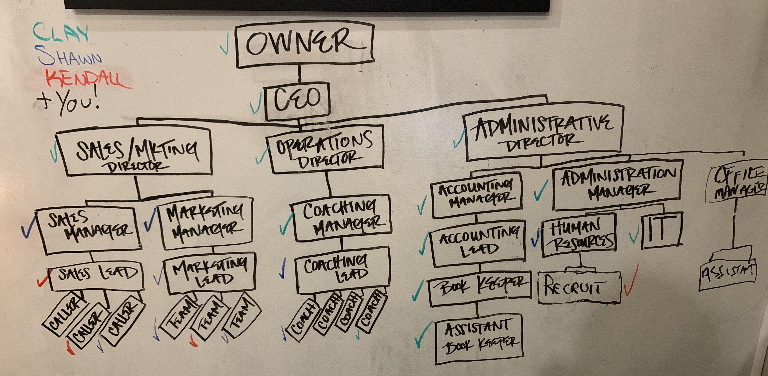

This chart reveals the layers of responsibility and accountability in our company. Each box represents a specific responsibility and the boxes they are connected to represent whom they are responsible for and to. It also reveals our paths of communication.

The Horizontal Layers represent the hierarchy of management authority and responsibility in our company.

- CEO and Directors – provide leadership for our company. They are responsible for Vision, Mission and Inspiration for the entire company. This level of management is also responsible for seeing out into the future 6 months to 6 years. This level of responsibility is accountable for the consistent direction and momentum of the company. The Directors are held accountable to producing all of our business systems that allow the company to run smoothly.
- Middle Managers – these managers are responsible for implementing the systems that are designed by the Directors. Middle Managers have direct daily connection with the Workers in the company. They act as “Firemen” because their primary task is to put out fires that are created each day. Middle Managers are primarily focused on this week or maybe even this month. Through Team Building and proper daily management, these middle managers ensure that the right work is getting done by the right people.

- Team Leaders – Often, Workers have aspirations to move up in the company. The Team Leader is the first promotion in our company. The Team Leader has proven their ability to do the work and to follow instructions. Team Leaders have also shown the capacity to influence others and “gather” people to them. Team Leaders are not only able to do the work, but they have the ability to get other people to do the work along with them. This is critical in the promotion process.

- Workers – the real hands of the company. Without Workers, nothing would get done. The responsibility of the Worker is to complete the work that is assigned to them each day. Workers are primarily focused on TODAY and the work that needs to get done right now. Often, the entry level (or proving ground) for most companies.

This chart also reveals paths for promotion and increased compensation. Remember, activity isn’t the measuring stick for promotion – PRODUCTION is the measuring stick! You may see “boxes” that you would like to fill. It’s important to let your manager know about what you would like to see in your future. We take that very seriously here at The Leadership Initiative. We’ll do all we can to help you get there!

Finally, the three primary branches (Vertical Columns) of our company are
- Sales and Marketing – responsible for bringing business into the company
- Operations – responsible for fulfilling the exceptional business once it comes in
- Administration – responsible for ensuring that the Sales/Marketing and Operations is consistently equipped with the resources needed to function successfully

You may want to consider these three branches of our company when thinking about your growth path.

Employee Expectations
“A small team of A+ players can run circles around a giant team of B and C players.” Steve Jobs
“If you pick the right people and give them the opportunity to spread their wings and put compensation as a carrier behind it you almost don't have to manage them.” Jack Welch

A, B, C Player Descriptions –
A-Players:
- They arrive to work early and stay until the job is done.
- They embrace ongoing learning and don’t push back when assigned something that is new and challenging because they like big challenges.
- They hold themselves to a higher standard than management does so they can show that they really don’t need a boss.
- They are hungry for more work and more obstacles to overcome.
- They are goal oriented and want to win.
- They have a growth-mindset that is focused on constant improvement.
- They consistently get their jobs done without broadcasting their emotional state to the room. With these people, you usually can’t tell whether they are going through a personal tragedy or have won life’s lottery because they will get their work done either way.
- They can’t stand to work around B- and C-players who represent mediocrity and people who are slowing them down.

B-Players:
- They arrive to work right on time and leave work right on time or two minutes early.
- They push back at the thought of ongoing learning and tend to ask if they are going to be paid for it because “it’s not technically part of their job description.”
- They hold themselves to the standard that management sets and actively demonstrates. They constantly compare themselves to their co-workers to justify their lack of effort and excellence.
- They don’t want more work and they spend any free time they have planning their next vacation.
- They are not goal oriented and they hope the company wins just enough so that they don’t have to look for another job.
- They have a fixed mindset that is based upon their belief that each person is born with a certain amount of skills and that is all there is to it.
- They consistently get their jobs done while bringing their up and down emotions to the workplace each day.
- They love working with other B- and C-Players who justify their slow work pace and whom they can go out to eat with and talk to about everything except for how to do their job better.

C-Players:
- They arrive to work 5 to 10 minutes late and always have a traffic-related, personal or medical excuse.
- They systematically make teaching them so hard that management gives up on them, but doesn’t fire them. Since they are branded “unteachable,” they get less put on their plates than anyone else.
- They have no standards and want to do the least amount of work possible during each workday. When you walk into the room, they minimize their social media and their chat room programs and pretend to be working.
- They find ways to leave work early every day and to take extended breaks. They fudge on the amount of time it takes for them to accomplish nearly every task and they need to be praised for just doing their job or they will have an emotional breakdown.
- They view success as based largely upon luck and they are actually bitter toward people who are more successful than they are.
- They have a fixed mindset that is based upon their belief that each person is born with a certain amount of skills and that is all there is to it.
- They only work hard when they emotionally feel like it, and they usually don’t.
- They love working with other B- and C-Players who justify their slow work pace and they go out of their way to spread gossip and negative feelings around the office to bring the room down to their way of thinking.

The Leadership Initiative Pay Scale:
What will my pay look like?
- Payroll –
  - You will be paid every two weeks on Friday.
  - You may pick up your check or it can be mailed to you or we can automatically deposit it. Be sure to inform Accounting of how you would like to receive your check.
  - Your pay will be on a Merit Based Pay System
    - Guaranteed Hourly Wage
    - Bonus Pay Structure based on Productivity
    - Bonus Dollars based on Productivity
Base Pay:
- $10/hr guaranteed - $20,800/yr
Bonus Pay – measured on a daily basis based on production
- $3/hr added for Exceeding Expectations (The Big Wow!) – Total of $13/hr or $27,000/yr
  - Quicker, Better, Remarkable Activity
- $2/hr added for Meeting Expectations – Total of $12/hr or approx. $25,000/yr
  - Completing all that you’re asked told to do in your job description and in your daily to do list.
Commissions –
You will get paid $20 for every appointment you set that leads to a presentation.
You will get 25% of any deal that closes based on you setting the appointment.

So…Considering the 40 hrs a week, each pay period:
80 hrs at $10/hr PLUS the Bonus for meeting or exceeding expectations which will be $2-$3/hr

So a perfect paycheck of exceeding expectations each day for two weeks would be...
$800 (80 hrs X $10/hr)
+$320 Bonus (80 hrs X $4/hr)
+ Commissions (as agreed upon)
Gross $1120 plus commissions (which can consistently be between $800 and $1500 a month)
This could potentially make your monthly gross paycheck over $3000 or approximately $36,000/yr.

A terrible paycheck would look like...
$800 plus $0 Bonus plus commissions (as agreed upon)

You and your manager will have a daily "touch point" to let you know if it was a
Below Expectation - $10/hr day ($80)
Meet Expectation - $12/hr day ($96) or the wage agreed upon
Exceed Expectation - $13/hr day ($104)
*This way there is no surprises and you can make quick adjustments to maximize your pay as you maximize performance. If, by chance, you don’t have the daily “touch point”, then you can assume it was a “meets expectation day”.

Salary For Coaches
The majority of TLI employees will be on a track to becoming a Business Coach. Our coaches get paid $50/hr for each hour they coach during the pay period (if a client cancels on you, you will still get paid for the hour). We have discovered that the maximum capacity for one coach is 20 clients a week.
When you cross over to being a coach, you will move to salary at $500/week. You will still receive the commissions from your phone calls (however, the number of phone calls required will be reduced when you’re coaching).
So, as a coach, your maximum paycheck every two weeks would look like this…
$500/week = $1000
40 client meetings x $50/meeting = $2000
Total Maximum Monthly Gross Salary = $6000 a month plus your commissions which can consistently be around $1000 month.
Annual Gross Salary = around $84,000

Logging Hours:
- Unless otherwise discussed, your workweek will be 40 hours (8 hours a day).
Damaged Equipment:
- You are responsible for maintaining the working order of all of your equipment and your actual workstation.
- You will be charged 100% of the replacement costs for all equipment that disappears or is reported as missing.
- You will be charged 100% of the replacement costs for all equipment that is damaged due to carelessness or accidental breakage.

Employee Proper Conduct & Interaction Policy
  - Employees are not allowed to date fellow employees. It just gets confusing.
  - Employees are not allowed to date clients. Ok, now this is just not right.
  - There should be no reason to contact fellow employees unless it is a manager or assistant manager contacting an employee reframing work.

Break Policy:
We don’t really take “breaks” here at The Leadership Initiative. Yes, we eat lunch, but that usually means eating at our desks. It’s just not in our culture to “stop” during the day. Production and Pace is vital for success and we are committed to staying focused on these each day. Yes, you can go to the bathroom. Yes, you can go “get food” and bring it back. Yes, you can walk around the building once or twice if you need, but the word “break” isn’t really in our vocabulary.

Social Media: While The Leadership Initiative encourages its employees to enjoy and make good use of time outside of work, certain activities on the part of employees may become a problem if they have the effect of impairing the work of any employee; harassing, demeaning, or creating a hostile working environment for any employee; disrupting the smooth and orderly flow of work within The Leadership Initiative; directly or indirectly disclosing confidential or proprietary information; or harming the goodwill and reputation of The Leadership Initiative among its customers or in the community at large. In the area of social media (print, broadcast, digital, and online), employees may use such media in any way they choose as long as such use does not produce the adverse consequences noted above. For this reason, The Leadership Initiative reminds its employees that the following guidelines apply in their use of social media, both on and off duty:
- If an employee publishes any personal information about themselves, another employee of The Leadership Initiative, a customer in any public medium (print, broadcast, digital, or online) that:
  - has the potential or effect of involving the employee, their co‐workers, or The Leadership Initiative in any kind of dispute or conflict with other employees or third parties;
  - interferes with the work of any employee;
  - creates a harassing, demeaning, or hostile working environment for any employee;
  - disrupts the smooth and orderly flow of work within the office, or the delivery of services to the company’s customers;
  - harms the goodwill and reputation of The Leadership Initiative among its customers or in the community at large;
  - tends to place in doubt the reliability, trustworthiness, or sound judgment of the person who is the subject of the information; or
  - reveals proprietary information or The Leadership Initiative trade secrets;
2. The employee(s) responsible for such problems will be subject to counseling and/or disciplinary action, up to and potentially including termination of employment, depending upon the circumstances.
3. No employee of The Leadership Initiative may use company equipment or facilities for furtherance of non‐work‐related activities or relationships without the express advance permission of Douglas Mitcho.
4. Be respectful to The Leadership Initiative, co‐workers, customers, clients, partners and competitors, and be mindful of your physical safety when posting information about yourself or others on any forum. Describing intimate details of your personal and social life, or providing information about your detailed comings and goings might be interpreted as an invitation for further communication ‐--or even stalking and harassment that could prove dangerous to your physical safety.
5. Social media activities should never interfere with work commitments.
6. Your online presence can reflect on The Leadership Initiative. Be aware that your comments, posts, or actions captured via digital or film images can affect the image of The Leadership Initiative.
7. Do not use any The Leadership Initiative logos or trademarks without written consent.
Welcoming a Client at the Office: There will be times where you will have the opportunity to greet a client or a guest of The Leadership Initiative. Please greet them this way if you don’ t know them -
Hello, my name is _________________?
Are you here to see Clay?
What’s your name?
Hello, ________________. Its nice to meet you and it’s very nice to have you here today.
May I get you something to drink – water, soda, diet?
Please have a seat and I’ll let Clay know you’re here.

If you do know them, please greet them by name (Mr. or Mrs.).
Offer them something to drink and ask them to have a seat and that you’ll let Clay know they are here.

Employee Parking: Employees should park on the West side of the building.
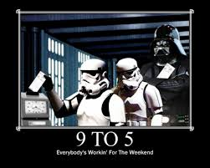
Clocking in and out: We don’t do the “Clock in and out” thing here at The Leadership Initiative. Our workday begins at 7 and finishes at 5. It is suggested you arrive 15 minutes early to prepare for the day. Most days will include a Daily Morning Huddle Meeting and a 5:00 Wrap Up Meeting. Each of these meetings last about 5-10 minutes.

SICK DAYS & TIME OFF
At The Leadership Initiative, our goal is to make sure that we can offer both employees and customers alike a stable and dependable coaching environment. In order to do that we need you to be here each day. You need the steady revenue stream and we need the steady production stream. However, life happens. If you get sick you need to talk with your manager immediately. This has to be a direct conversation – no text, emails, leaving a message, telling a friend to tell your manager, etc.
There must be a complete circle of communication – you talk with them and they respond back to you. One way communication will not be an acceptable excuse.

Time Off Policy:

Yearly Employee Time Off:
- All employees are allowed 7 unpaid vacations days per year.

Request Time Off Steps:
- Step 1: Employee must submit time request off to Manager. Please don’t “spring” this on us.
- Step 2: Your manager must sign off on your request acknowledging that your requested time off has been approved.
- Step 3: Manager approves and makes a copy for employee file.
- Step 4: Manager receives the approved form and returns to Employee. (Complete Circle of Communication)
- An appropriate time to give prior to needing time off is 30 days.
- Employees may not take off both the day before the holiday and the day after the holiday simultaneously.
- Managers and Assistant Managers are expected to not take extended vacations during the holidays.
- Sending a text to a Manager is not an acceptable means to call in sick or to ask for time off. You must speak with your Manager over the phone.
- Managers cannot leave unless there is another manager present.
- If you have three unexcused absences within 1 year, it will result in termination. The absences will be based off a rolling calendar year. That means they expire 1 year after the original unexcused absence date.
- Life happens, we get it. If you have appointments that must be scheduled during the workday, we expect you to notify us so we can be informed. These appointments need to be approved – yes, life happens, but we need to be sure to communicate. If you need off for vacation or other personal reasons, please get approval 30 days ahead.
- No show No call = Grounds for termination.
- Management will determine on a case-by-case basis any absence that would be considered an emergency and not require the 24 hour advance call to the Manager.
- Failure to give a two-week advanced notice when deciding to stop working at The Leadership Initiative will result in the loss of training pay and for your final pay period being reduced to $8.00 per hour.
- Employees that provide a two week advanced notice, and begin to encourage The Leadership Initiative clients to follow them to their new place of employment shall be immediately terminated and their last paycheck will be adjusted to a minimum wage level.

Employee On-Time / Late Policy:
- Arrival fully-dressed 15 minutes before the workday is considered “on-time.”
- If you NO SHOW and NO CALL you are automatically terminated.
- “A man has no right to occupy another man's time unnecessarily.” - John D. Rockefeller (World's wealthiest man during his lifetime)

Pay Day:
Pay day will be every two weeks on Friday and will be distributed at the end of the day. You may choose to receive your paycheck through an automatic deposit or you may choose to receive an actual check.
Every employee must pick up their check in person. No one else will be allowed to pick up your check. Please verify that your check is correct at the time of pick-up. If there are any discrepancies, please make the Store Manager aware of this when you pick up your check. Otherwise, it will be considered to be correct.

Customer Privacy Policy:
- Client Data Privacy: All client information is private and confidential and is not used for personal gain.

Computer Policy:
- You may choose to use your personal computer at your desk. However, a computer will be made available to each employee with all the necessary programs to complete your job. If you choose to use your own computer, The Leadership Initiative is not responsible for any negative impact that may occur and will not be responsible for repair/replacement costs.
- Our server is monitored so please ensure that your computer usage remains appropriate. Inappropriate surfing could be grounds for termination and will definitely be embarrassing when we confront you.

Food Policy:
- You may eat at your desk. Be sure to clean up after yourself and maintain a clean workstation.

Discipline Policy:
- An employee who violates the rules of the company, or who willingly demonstrates insubordinate behavior will have each incident documented by their manager.
- The manager will then talk to the employee who is demonstrating the insubordinate behavior in an attempt to correct the behavior.
- Manager will file documentation through an email to upper management.

Signature Page
Employee Handbook

I accept all of the policies stated in the Employee Handbook. I will abide by the rules of The Leadership Initiative and Creamery. I also understand that failing to abide by these rules could result in my termination of employment from The Leadership Initiative and Creamery. Further, I understand that this handbook is not all inclusive and may change from time to time. I also understand that by signing this form, I am not entering into any contractual agreement of employment with the company and I or the company may terminate my employment at any time for any reason or no reason.

Employee: _________________________

Date: ______________________________

LEGAL PAGES
DRUG AND ALCOHOL FREE WORKPLACE POLICY
The Leadership Initiative Policies strive to provide a safe work environment and encourage personal health. In keeping with this policy, the company considers the abuse of drugs or alcohol on the job to be an unsafe and a counterproductive work practice. It is, therefore, company policy that an employee detected to have alcohol or illegal drugs in his/her system, in possession of, using, selling, trading, or offering for sale illegal drugs or alcohol during work hours, will be subject to disciplinary action including discharge. (Company sponsored activities which may include the service of alcoholic beverages are not included in this provision. Discretion should be exercised by the employee to avoid overindulging in the consumption of alcohol.) Substance Abuse includes possession, use, purchase, or sale of drugs or alcohol on company premises (including parking lots).
Employees will be required to submit to drug and/or alcohol testing at a laboratory chosen by the company for the following reasons:
  - Observed alcohol or drug abuse during work hours on company premises.
  - Apparent physical state of impairment.
  - Incoherent mental state.
  - Accident or other actions that provide reasonable cause to believe the employee may be under the influence.
  - As required by any government programs such as the US Department of Transportation.

In addition to testing for the purposes above, The Leadership Initiative reserves the right to randomly test employees. Refusal to such testing will subject an employee to disciplinary action up to and including termination of employment.
HARASSMENT
The Leadership Initiative is a zero tolerance for and therefore prohibit all forms of illegal harassment of employees by managers, fellow employees, and employees of contractors and/or visitors including any demeaning, insulting, embarrassing or intimidating behavior directed at any employee because of their sex, race, age, nationality, religion or disability.
Sexual harassment is defined as unwelcome sexual advances, requests for sexual favors, and other verbal or physical conduct of a sexual nature when (1) submission to such conduct is made, either explicitly or implicitly, a term or condition if an individual’s employment, (2) submission to or rejection of such conduct by an individual is used as the basis for employment decisions affecting such individual, or (3) such conduct has the purpose or effect of substantially interfering with an individual’s work performance or creating an intimidating, hostile, or offensive working environment.
Sexual harassment can take two distinct forms: quid pro quo and hostile work environment.
  - Quid pro quo harassment occurs when submission to sexual conduct is made a condition of employment or employment benefits.
  - Hostile work environment occurs when sexual conduct unreasonably interferes with an employee’s work performance or creates an intimidating, abusive, or offensive work environment.

Sexual harassment includes verbal harassment, such as epithets, derogatory comments, or slurs; physical harassment, such as assault, impeding or blocking movement, or any physical interference with normal work movement and visual harassment, such as derogatory posters, cartoons, or drawings. Emotional harassment which includes emotional manipulation, stalking, and refusing to stop unwelcomed contact.
The Leadership Initiative will take incidents of alleged sexual harassment seriously, with follow-up investigation and appropriate corrective action if necessary.
REPORTING PROCEDURE
Any individual who believes he/she is subject to sexual harassment, or believes sexual harassment may be taking place whether or not it directly affects that individual, must report the circumstances as soon as possible to any one of the following: immediate Supervisor, Human Resources Administrator, Officer of the Company, or any person designated in the Employee Handbook as a Contact Person. Upon completion of any investigation, The Leadership Initiative will take appropriate action.
Contact Person other than Clay Staires, is Scott Reib – The Leadership Initiative Attorney – 940-591-0600
ADA and ADAA POLICY
The Leadership Initiative is committed to complying fully with the Americans Disabilities Act (ADA) and ensuring equal opportunity in employment for qualified persons with disabilities. All employment practices and activities are conducted on a non-discriminatory basis.
Hiring procedures have been reviewed and provide persons with disabilities meaningful employment opportunities. Pre-employment inquiries are made only regarding an applicant’s ability to perform the essential duties of the position.
The Leadership Initiative will provide reasonable accommodation to the known disabilities of any employee; if such accommodation is required in order for the employee to perform the essential functions of the employee’s job and accommodation would not cause undue hardship on the company. All employment decisions are based in the merit of the situation in accordance with defined criteria, not the disability of the individual.
Qualified individuals with disabilities are entitled to equal pay and other forms of compensation (or changes in compensation) as well as equal treatment in job assignments, classifications, organizational structures, position descriptions, and lines of progression. Leave of all types will be available to all employees on an equal basis.
The Leadership Initiative is also committed to not discriminating against any qualified employees or applicants because they are related to or associated with a person with a disability. The Leadership Initiative will follow any state or local law that provides individuals with disabilities greater protection than the ADA.
This policy is neither exhaustive nor exclusive. The Leadership Initiative is committed to taking all other actions necessary to ensure equal employment opportunity for persons with disabilities in accordance with the ADA and all other applicable federal, state, and local laws.
REQUESTING AN ACCOMMODATION
If an employee feels that they are in need of accommodations, they should contact their immediate supervisor/manager, Human Resource Administrator, Officer or Owner of the Company, or any other person in the Employee Handbook designated as a contact.
PAYROLL DEDUCTIONS
The following mandatory deductions will be made from every employee’s gross wages: federal income tax, Social Security FICA tax, and applicable city and state taxes.
Every employee must fill out and sign a federal withholding allowance certificate, IRS Form W-4, on or before his or her first day on the job. This form must be completed in accordance with federal regulations.
The employee may fill out a new W-4 at any time when his or her circumstances change. Employees who paid no federal income tax for the preceding year and who expect to pay no income tax for the current year may fill out an Exemption from Withholding Certificate, IRS Form W-4E. Employees are expected to comply with the instructions on Form W-4. Questions regarding the propriety of claimed deductions may be referred to the IRS in certain circumstances
Other optional deductions include the portion of group health insurance not paid by the company, which is deducted from each payroll check. Other voluntary contributions, such as credit union and pension plan, are also deducted each pay period. Any other deductions from pay require your voluntary, written and specific authorization to do so.

Employee Acknowledgement of Legal Guidelines
I have received my copy of The Leadership Initiative Policies that outlines the policies, practices, and guidelines of the company, and I have read and I understand the information contained in the manual.
Since the information in these policies is subject to change as situations warrant, it is understood that changes in the manual may supersede, revise, or eliminate one or more of the policies in these policies. These changes will be communicated to me by my supervisor/manager or through official notices. I accept responsibility for keeping informed of these changes.
I further acknowledge my understanding that my employment The Leadership Initiative Policies is considered at will and may be terminated at any time with or without cause. Only official executed, legally binding contracts of employment supersede employment at will.
Employee’s Signature: _____________________________
Date: _____________________
Name (Please Print): _________________________________

CONFIDENTIALITY AGREEMENT
This Confidentiality Agreement (the “Agreement”) is made effective as of the date set forth on the signature page hereto by and between The Leadership Initiative, INC., an Oklahoma corporation (“The Leadership Initiative”) and the undersigned employee (“Employee”).
Employee is or will become an employee of The Leadership Initiative (the “Employment”). During the course of the Employment, Employee will receive certain confidential, proprietary information related to The Leadership Initiative, its operations, and/or the proprietary methods for establishing, operating, and promoting The Leadership Initiative Businesses (the “Licensed Methods”). The Leadership Initiative is willing to proceed with the Employment as long as Employee is willing to maintain the confidentiality of this proprietary information as follows:

EMPLOYMENT AGREEMENT

This Employment Agreement (this "Agreement") is made effective as of _________________, by and between Clay Staires, LLC ("Employer"), of 3939 South Harvard Avenue #125, Tulsa, Oklahoma. and _________________________ ("Employee"), of _________________, _________________, _________________, _________________.

A. Employer is engaged in the business of Speaking and Business Consulting. Employee will primarily perform the job duties at the following location: 3939 South Harvard Avenue #125, Tulsa, Oklahoma.

B. Employer desires to have the services of Employee.

C. Employee is an at will employee of Employer. Either party is able to terminate the employment agreement at any time.

Therefore, the parties agree as follows:

1. EMPLOYMENT. Employer shall employ Employee as a(n) ____________________________________________. Employee agrees to be available at least ___ hours per week. Employee shall provide to Employer the services described on the attached Exhibit A, which is made a part of this Agreement by this reference. Employee accepts and agrees to such employment, and agrees to be subject to the general supervision, advice and direction of Employer and Employer's supervisory personnel. Employee shall also perform (i) such other duties as are customarily performed by an employee in a similar position, and (ii) such other and unrelated services and duties as may be assigned to Employee from time to time by Employer.

2. BEST EFFORTS OF EMPLOYEE. Employee agrees to perform faithfully, industriously, and to the best of Employee's ability, experience, and talents, all of the duties that may be required by the express and implicit terms of this Agreement, to the reasonable satisfaction of Employer. Such duties shall be provided at such place(s) as the needs, business, or opportunities of Employer may require from time to time.

3. OWNERSHIP OF SOCIAL MEDIA CONTACTS. Any social media contacts, including "followers" or "friends," that are acquired through accounts (including, but not limited to email addresses, blogs, Twitter, Facebook, YouTube, or other social media networks) used or created on behalf of Employer are the property of Employer.

4. COMPENSATION OF EMPLOYEE. As compensation for the services provided by Employee under this Agreement, Employer will pay Employee a minimum of $_____ per hour and a maximum of $_____ per hour. (Refer to Job Description for salary and bonus structure) This amount shall be paid in accordance with Employer's usual payroll procedures and subject to applicable federal, state, and local withholding. Upon termination of this Agreement, payments under this paragraph shall cease; provided, however, that Employee shall be entitled to payments for periods or partial periods that occurred prior to the date of termination and for which Employee has not yet been paid, and for any commission earned in accordance with Employer's customary procedures, if applicable. This section of the Agreement is included only for accounting and payroll purposes and should not be construed as establishing a minimum or definite term of employment.

5. EXPENSE REIMBURSEMENT. Employer will reimburse Employee for "out-of-pocket" expenses incurred by Employee in accordance with Employer's policies in effect from time to time.

6. RECOMMENDATIONS FOR IMPROVING OPERATIONS. Employee shall provide Employer with all information, suggestions, and recommendations regarding Employer's business, of which Employee has knowledge that will be of benefit to Employer.

7. CONFIDENTIALITY. Employee recognizes that Employer has and will have information regarding the following:

- trade secrets
- copyrights
- customer lists
- prices
- costs
- discounts
- business affairs
- future plans
- user names and passwords
- processes
- technical matters
- business records and plans,
- trade secrets, technical data,
- product ideas,
- contracts,
- financial information,
- pricing structure,
- discounts,
- trade secrets
- copyrights and intellectual property, inventions,
- sales leads,
- strategic alliances,
- partners, and customer and client lists; and
- other vital information items (collectively, "Information") which are valuable, special and unique assets of Employer.
Employee agrees that Employee will not at any time or in any manner, either directly or indirectly, divulge, disclose, or communicate any Information to any third party without the prior written consent of Employer. Employee will protect the Information and treat it as strictly confidential. A violation by Employee of this paragraph shall be a material violation of this Agreement and will justify legal and/or equitable relief.

8. UNAUTHORIZED DISCLOSURE OF INFORMATION. If it appears that Employee has disclosed (or has threatened to disclose) Information in violation of this Agreement, Employer shall be entitled to an injunction to restrain Employee from disclosing, in whole or in part, such Information, or from providing any services to any party to whom such Information has been disclosed or may be disclosed. Employer shall not be prohibited by this provision from pursuing other remedies, including a claim for losses and damages.

9. CONFIDENTIALITY AFTER TERMINATION OF EMPLOYMENT. The confidentiality provisions of this Agreement shall remain in full force and effect for a 2-year period after the voluntary or involuntary termination of Employee's employment. During such 2-year period , neither party shall make or permit the making of any public announcement or statement of any kind that Employee was formerly employed by or connected with Employer.

10. NON-SOLICITATION.

A. During the term of the Employee’s employment under this Agreement and for a 2-year period thereafter following the termination of the Employee providing any services to the Company, whether such termination be by the Company or by the Employee, the Employee will not directly or indirectly (i) recruit, solicit, encourage, or induce any employee of the Company or its affiliates to terminate such employment (ii) approach any such person for any foregoing purposes, (iii) otherwise disrupt any such employee’s relationship with the Company or its affiliates.

B. During the term of the Employee’s employment under this Agreement and for a period of twenty-four (24) months thereafter or, if longer, a period of twenty-four (24) months following the termination of the Employee providing any services to the Company, whether such termination be by the Company or by the Employee, the Employee will not directly or indirectly (i) recruit, solicit, encourage, or induce any customer’s of the Company or its affiliates to terminate their relationship with Employer; (ii) approach any such person for any foregoing purposes, (iii) otherwise disrupt any such customer’s relationship with the Company or its affiliates.

C. During the term of the Employee’s employment under this Agreement and for a period of twenty-four (24) months thereafter or, if longer, a period of twenty-four (24) months following the termination of the Employee providing any services to the Company, whether such termination be by the Company or by the Employee, the Employee will not directly or indirectly (i) recruit, solicit, encourage, or induce any of Employer's social media contacts with clients, customers and co-workers to terminate or change their status in social media with Employer; (ii) approach any such person for any foregoing purposes, (iii) otherwise disrupt any such contact’s relationship with the Company or its affiliates.

D. During the term of the Employee’s employment under this Agreement and for a period of twenty-four (24) months thereafter or, if longer, a period of twenty-four (24) months following the termination of the Employee providing any services to the Company, whether such termination be by the Company or by the Employee, the Employee will not directly or indirectly (i) recruit, solicit, encourage, or induce any of employees' social media contacts with clients, customers and co-workers to terminate or change their status in social media with Employer; (ii) approach any such person for any foregoing purposes, (iii) otherwise disrupt any such contact’s relationship with the Company or its affiliates.

11. EMPLOYEE'S INABILITY TO AGREEMENT FOR EMPLOYER. Employee shall not have the right to make any Agreements or commitments for or on behalf of Employer without first obtaining the express written consent of Employer.

12. TERM/TERMINATION. Employee's employment under this Agreement shall be for an unspecified term on an "at will" basis. If Employee is in violation of this Agreement, Employer may terminate employment without notice and with compensation to Employee only to the date of such termination. The compensation paid under this Agreement shall be Employee's exclusive remedy.

13. TERMINATION FOR DISABILITY. Employer shall have the option to terminate this Agreement, if Employee becomes permanently disabled and is no longer able to perform the essential functions of the position with reasonable accommodation. Employer shall exercise this option by giving 10 written notice to Employee.

14. COMPLIANCE WITH EMPLOYER'S RULES. Employee agrees to comply with all of the rules and regulations of Employer.

15. RETURN OF PROPERTY. Upon termination of this Agreement, Employee shall deliver to Employer all property which is Employer's property or related to Employer's business (including keys, records, notes, data, memoranda, models, and equipment) that is in Employee's possession or under Employee's control. Such obligation shall be governed by any separate confidentiality or proprietary rights agreement signed by Employee.

16. NOTICES. All notices required or permitted under this Agreement shall be in writing and shall be deemed delivered when delivered in person or on the third day after being deposited in the United States mail, postage paid, addressed as follows:

Employer:

Clay Staires, LLC
Clay Staires
President
3939 South Harvard Avenue #125
Tulsa, Oklahoma

Employee:

_________________
_________________
_________________
_________________

Such addresses may be changed from time to time by either party by providing written notice in the manner set forth above.

16. ENTIRE AGREEMENT. This Agreement contains the entire agreement of the parties and there are no other promises or conditions in any other agreement whether oral or written. This Agreement supersedes any prior written or oral agreements between the parties.

17. AMENDMENT. This Agreement may be modified or amended, if the amendment is made in writing and is signed by both parties.

18. SEVERABILITY. If any provisions of this Agreement shall be held to be invalid or unenforceable for any reason, the remaining provisions shall continue to be valid and enforceable. If a court finds that any provision of this Agreement is invalid or unenforceable, but that by limiting such provision it would become valid or enforceable, then such provision shall be deemed to be written, construed, and enforced as so limited.

19. WAIVER OF AGREEMENTUAL RIGHT. The failure of either party to enforce any provision of this Agreement shall not be construed as a waiver or limitation of that party's right to subsequently enforce and compel strict compliance with every provision of this Agreement.

20. APPLICABLE LAW. This Agreement shall be governed by the laws of the State of Oklahoma.

21. SIGNATORIES. This Agreement shall be signed by Clay Staires, President on behalf of Clay Staires, LLC and by Joshua in an individual capacity. This Agreement is effective as of the date first above written.

___________________________________ Date: ______________________
Clay Staires

____________________________________ Date: ______________________

